**Exercise No:** 8

**Register No**: 1518102067

**Date:** 20/11/2020

**Aim:** To write a python program to get list,sorted in incresing orderby the last element in each tuple from the given list of non empty tuples.

**Program:**

lst=[]

list1=int(input("Enter no. of elements:"))

for x in range(0,list1):

val=int(input())

lst.append((val,pow(val,3)))

lst1=sorted(lst)

print(lst)

print(lst1)

**Link:** [**http://103.53.53.18/mod/vpl/forms/submissionview.php?id=317&userid=1682**](http://103.53.53.18/mod/vpl/forms/submissionview.php?id=317&userid=1682)

**Output:**

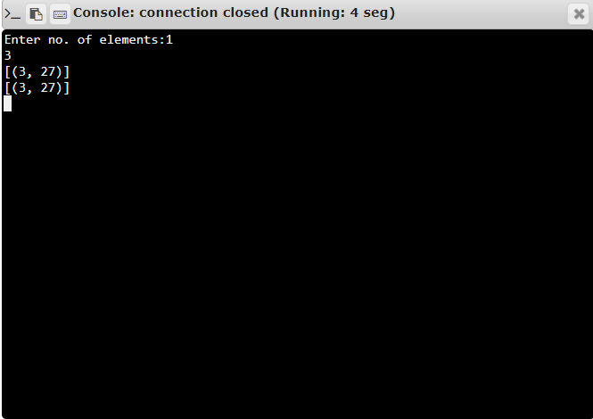

**Result:** Thus the program is executed sucessfully and the output is verified.